
Company
Logotype

Cone Beam Computed Tomography- Report



Porur Dental X-rays & CBCT

Patient Name : Mrs. Manjupriya | Date of Report : 30.10.2024
Age/ Gender : 32 years/ Female | Region of Interest : CBCT Full Skull
Referring doctor: Dr. C. Deepak | Indication : Post extraction swelling in left side
Clinical Notes: Nil
PATIENT INFORMATION

CBCT- Full Skull provided
CBCT – IMAGE DETAILS

RADIOGRAPHIC INTERPRETATION

- Completely missing crown and root portion in relation to 18, 28, 38, 48.
- The edentulous ridge of 28 and 38 are present with intact lamina dura and divergent socket.
- Distance between the edentulous 38 region and inferior alveolar nerve ridge is 3.34mm.
- The maxillary alveolar ridge is present with normal trabecular pattern.

RADIOGRAPHIC IMPRESSION

- Partially edentulous region: 18, 28, 38, 48.

Kindly correlate with clinical findings


IMAGES FOR REFERENCE

RECONSTRUCTED PANORAMIC VIEW
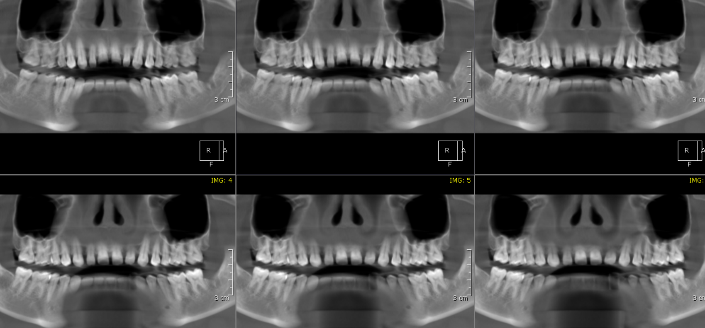

3-DIMENSIONAL VIEW

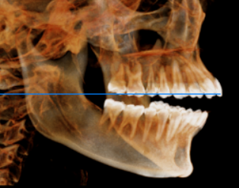
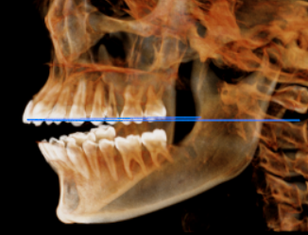

CROSS SECTIONAL VIEW

28 region and 38 region | 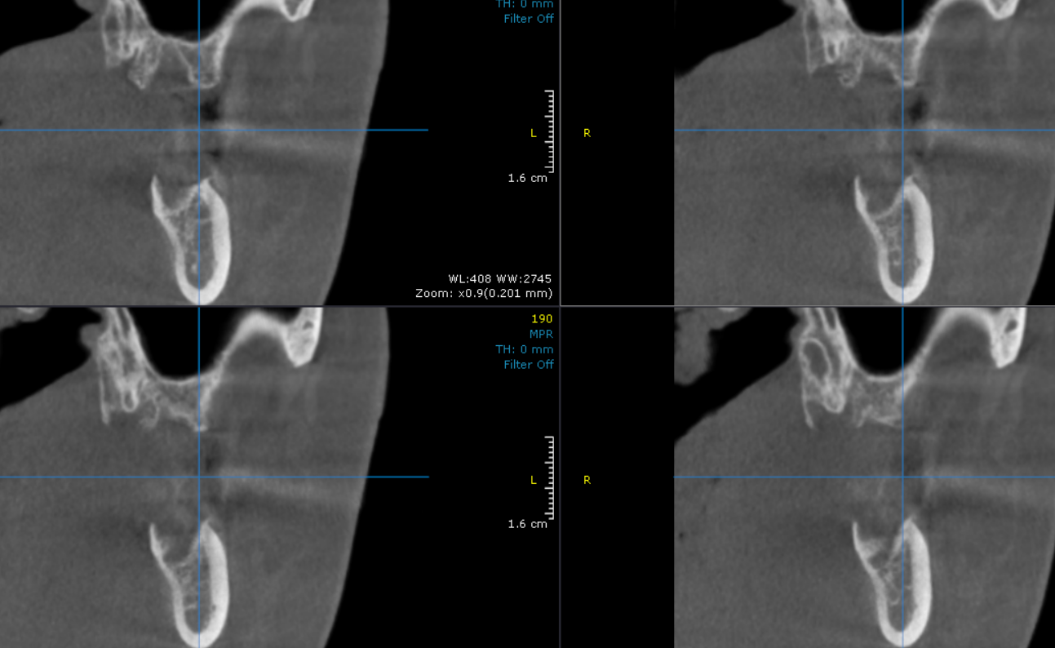

**** End of report ****

